# Objective:

# To implement a Monte Carlo simulation in a spreadsheet and visualize the results using a graph.

# To generate Random Number in a certain range.

# Experiment 1: Monte Carlo Simulation using Spreadsheet

# Procedure:

1. **Generate Random Numbers:**
   * Created two columns (Column C and Column D) with 500 random numbers each.
   * Formula used to generate random numbers:

▪ =1-2*RAND()

# Circle Equation Validation:

* + Added another column to check if points fall inside the unit circle.
  + Formula used:

▪ =IF((A1*A1+B1*B1) < 1, A1, 0)

This checks if the point lies within the circle by evaluating if x^2 + y^2 < 1.

* + A similar column was created for the second coordinate:

▪ =IF((A1*A1+B1*B1) < 1, B1, 0)

# Graphical Representation:

* + Plotted a graph using the validated data points.
  + The resulting graph displayed a circle consisting of 1000 discrete points.

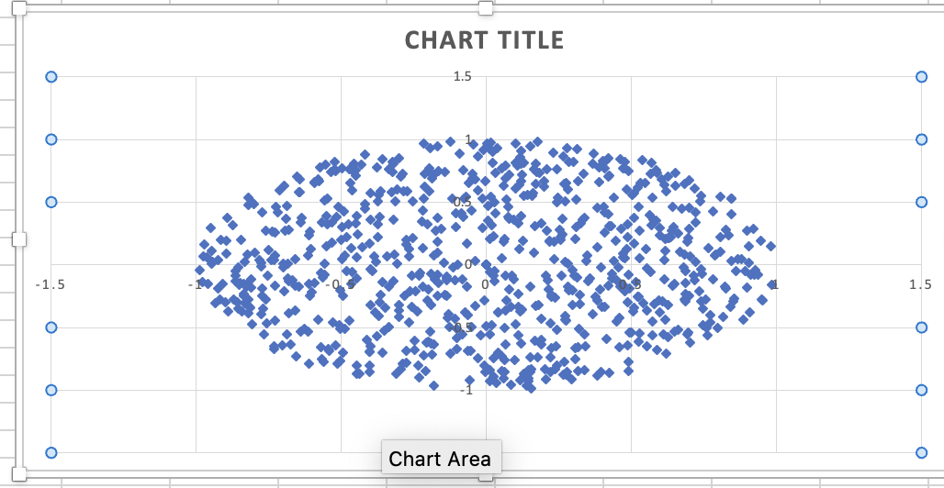

**Results:** The visualization successfully showed a circle formed by random points within the boundary of x^2 + y^2 = 1, validating the implementation.

# Experiment 2: Random Number Generation in a Range

**Objective:** To generate a series of random numbers within a user-defined range using C.

# Code Implementation:

#include <stdio.h>

#include <stdlib.h>

#include <time.h>

#include<conio.h>

void printRandoms(int min, int max, int count)

{

srand(time(0));

printf("Random number between %d and %d\n", min, max);

for (int i = 0; i < count; ++i)

{

int randomNum = min + rand() % (max - min + 1);

printf("%d ", randomNum);

}

printf("\n");

}

int main()

{

int min, max, count;

printf("Enter minimum value: ");

scanf("%d", &min);

printf("Enter maximum value: ");

scanf("%d", &max);

printf("Enter number of random numbers to generate: ");

scanf("%d", &count);

printRandoms(min, max, count);

return 0;

}

**Output:**

*Enter minimum value: 100*

*Enter maximum value: 200*

*Enter number of random numbers to generate: 20*

*Random number between 100 and 200*

*184 195 186 194 180 106 155 149 156 103 145 172 168 139 161 180 149 178 113 121*

# Results:

* Successfully generated a series of random numbers within the specified range.
* The user can define the range and count of numbers as inputs.

# Conclusion:

In this lab session, we explored Monte Carlo simulations and random number generation using both spreadsheet tools and C programming. The key takeaways include: The use of random number generation for simulation purposes.

* Estimating mathematical constants like π using the Monte Carlo method.
* Implementing practical programs to generate random data for various applications.
* Visualizing results through graphs and interpreting them effectively.

These exercises provide a foundation for understanding simulation and modeling techniques in computational and statistical applications.